Class: Agricultural Mechanics |  | Date:
Unit: Basic Woodworking |  | Lesson Title: Constructing a Tilt-Table
Content Standard Alignment:
- CS.03.04.01.b. Analyze and demonstrate adherence to protective equipment requirements when using various AFNR tools and equipment.
- C3.06.04.02.c. Evaluate and select appropriate tools and equipment to complete AFNR tasks.
- PST.01.02.03.b. Select, maintain and demonstrate the proper use of tools, machines and equipment used in different AFNR related mechanical systems.
Lesson Objectives/Instructional Outcomes:
- Given adequate instruction and resources, students will construct a mini tilt table to simulate tractor rollover angles.
- Students will demonstrate safe power tool/equipment use.
Relationship to Unit Structure:
This lesson builds upon previous discussions regarding general woodworking tool/equipment usage and associated safety PPE in a basic agricultural mechanics laboratory.
Instructional Materials/Resources: Per group
- Mini Table Build Plan
- 10” x 10” x 15/32” plywood pieces (2)
- 7.5” x 6” plywood piece (1)
- Rectangular Hinges 1.5” x 1” (2) – screws included in packaging (Gate House Part #0311942)
- Cabinet lid support (1) – screws included in packaging (Gate House Part #0311975)
- ½” Pan Head Philips screw (2) – replaces two of the screws from the cabinet lid support
- 1 inch wood screws (2)
Methods and Instructional Strategies
Anticipated Student Misconceptions:
Concept Prerequisites:
- Knowledge of safe power tool/equipment usage.

Introduction-  Anticipatory Set: | Outline the project, including the rationale and use of the tilt-table and its part in the next lesson (tractor rollovers). Address areas where mistakes may be made: i.e. mounting the cabinet lid supports or scale gauge incorrectly.
Instructional Activities:  Includes questioning techniques, grouping strategies, and pedagogical approaches. | Students work in groups of 3-4 to build and demonstrate tilt table. Groups will be formed on the basis of experience. Students with more experience will be grouped with students with less (peer-instruction). Students will be given instructions and will construct the table as a group. All students must have a task they are responsible for in the construction of the project.
Wrap Up-  Synthesis/Closure: | Students will perform a short test of their tables to ensure that they operate smoothly and will be sufficient for the next lesson.
Differentiation According to Student Needs:

Students will be grouped so that all groups have an experienced individual who can help the less experienced with the project. If desired, allow students to develop their own method for measuring the angles of the table.

Assessment (Formative and Summative):

No assessment will be used for this lesson other than function checks. The primary assessment for this lesson will be assimilated with the following lesson on angles and stability.

Equipment Rollover Safety Demonstration
Mini Tilt-Table Instructions

Purpose: Construct a mini-table that can demonstrate the effect of slopes on tractor rollover likelihood with varying centres of gravity.
Materials:

- 10” x 10” x 15/32” plywood pieces (2)
- 7.5” x 6” plywood piece (1)
- Rectangular Hinges 1.5” x 1” (2) – screws included in packaging (Gate House Part #0311942)
- Cabinet lid support (1) – screws included in packaging (Gate House Part #0311975)
- ½” Pan Head Philips screw (2) – replaces two of the screws from the cabinet lid support
- 1 inch wood screws (2)
- Eggs
- Adhesive Velcro strips
- Rubber bands

Directions:

Step 1: Mount Hinges
- Use the two 10” x 10” base pieces of plywood.
- Lay them side by side.
- Line up the hinges along the outside edges of the seam.
  - Make sure that hinges are aligned straight on the boards.
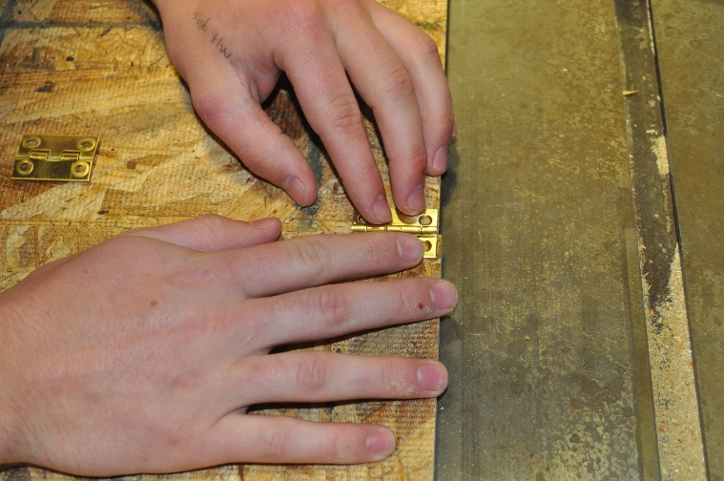
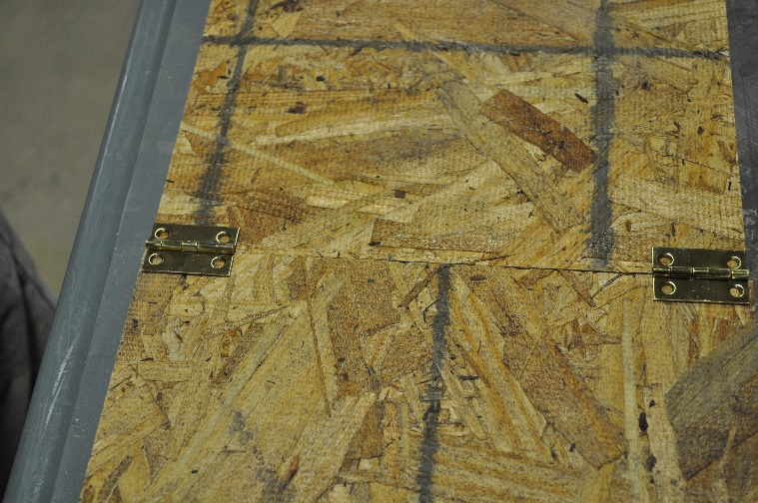
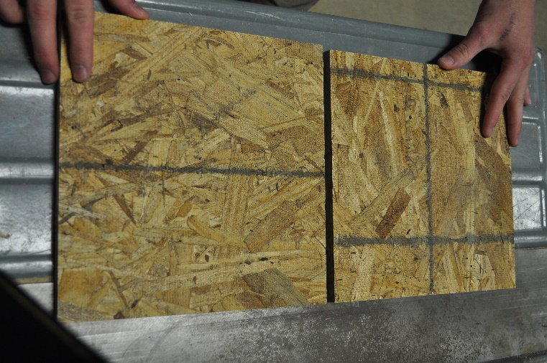
- Pre-drill your holes to make sure hinges are installed straight. If not, the pieces will not fold together properly.

Step 2: Realign the Lid Support
- Remove resistance adjustment screw from lid support.
- After flipping the resistance mechanism to the reverse side, replace resistance adjustment screw.
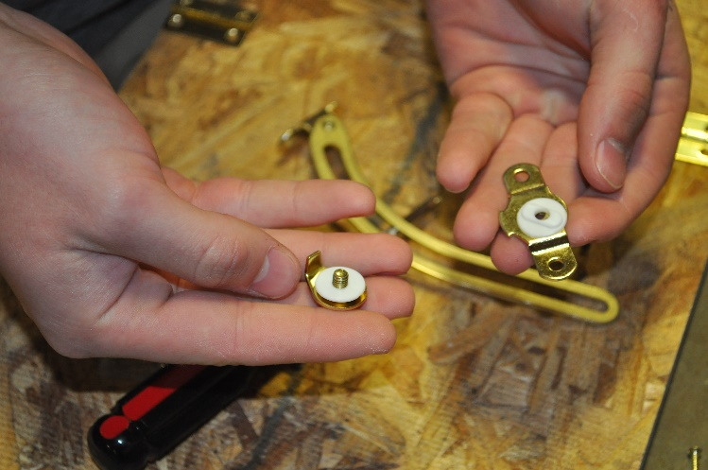
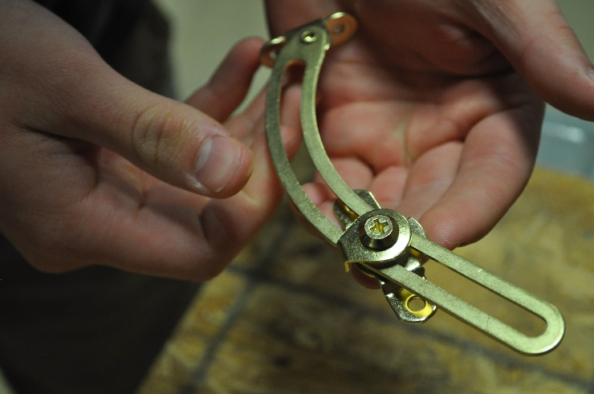
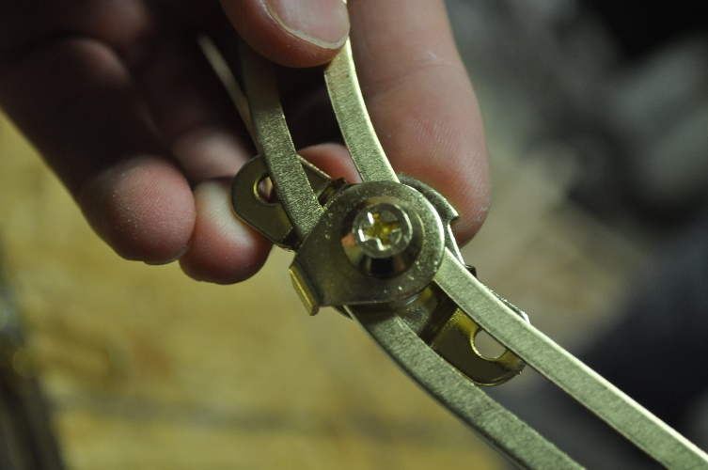
- When looking at the lid support, it will resemble a “J” with the screw on the right side.
Step 3: Mount the Lid Support
- Mount the lid support at 3 ¼” from the opposite edge of the hinges on the bottom board.
  - Use the ½” Pan Head Philips Screws (2) here instead of the packaged ones.
  - Leave a little bit of the hardware overhang the plywood. If not, the top board will bind on the hardware.
- Mount the resistance mechanism 2 ½” from the edge of the hinge side on the top board.
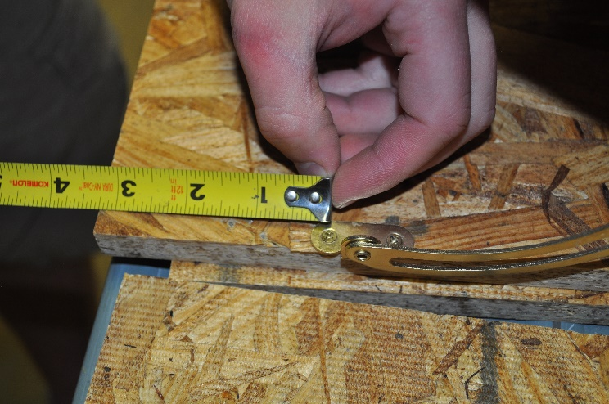
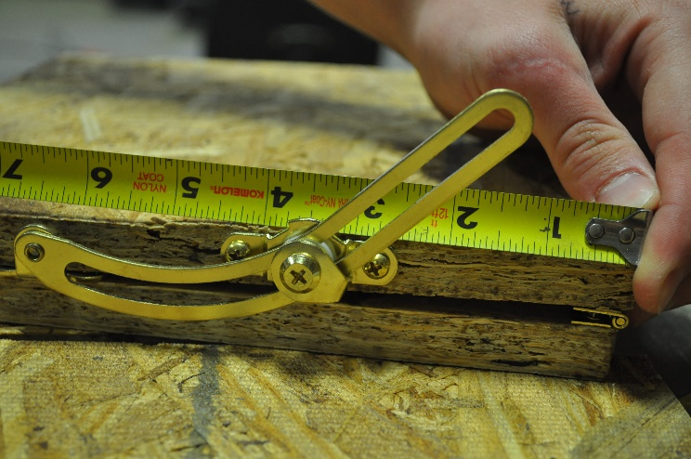
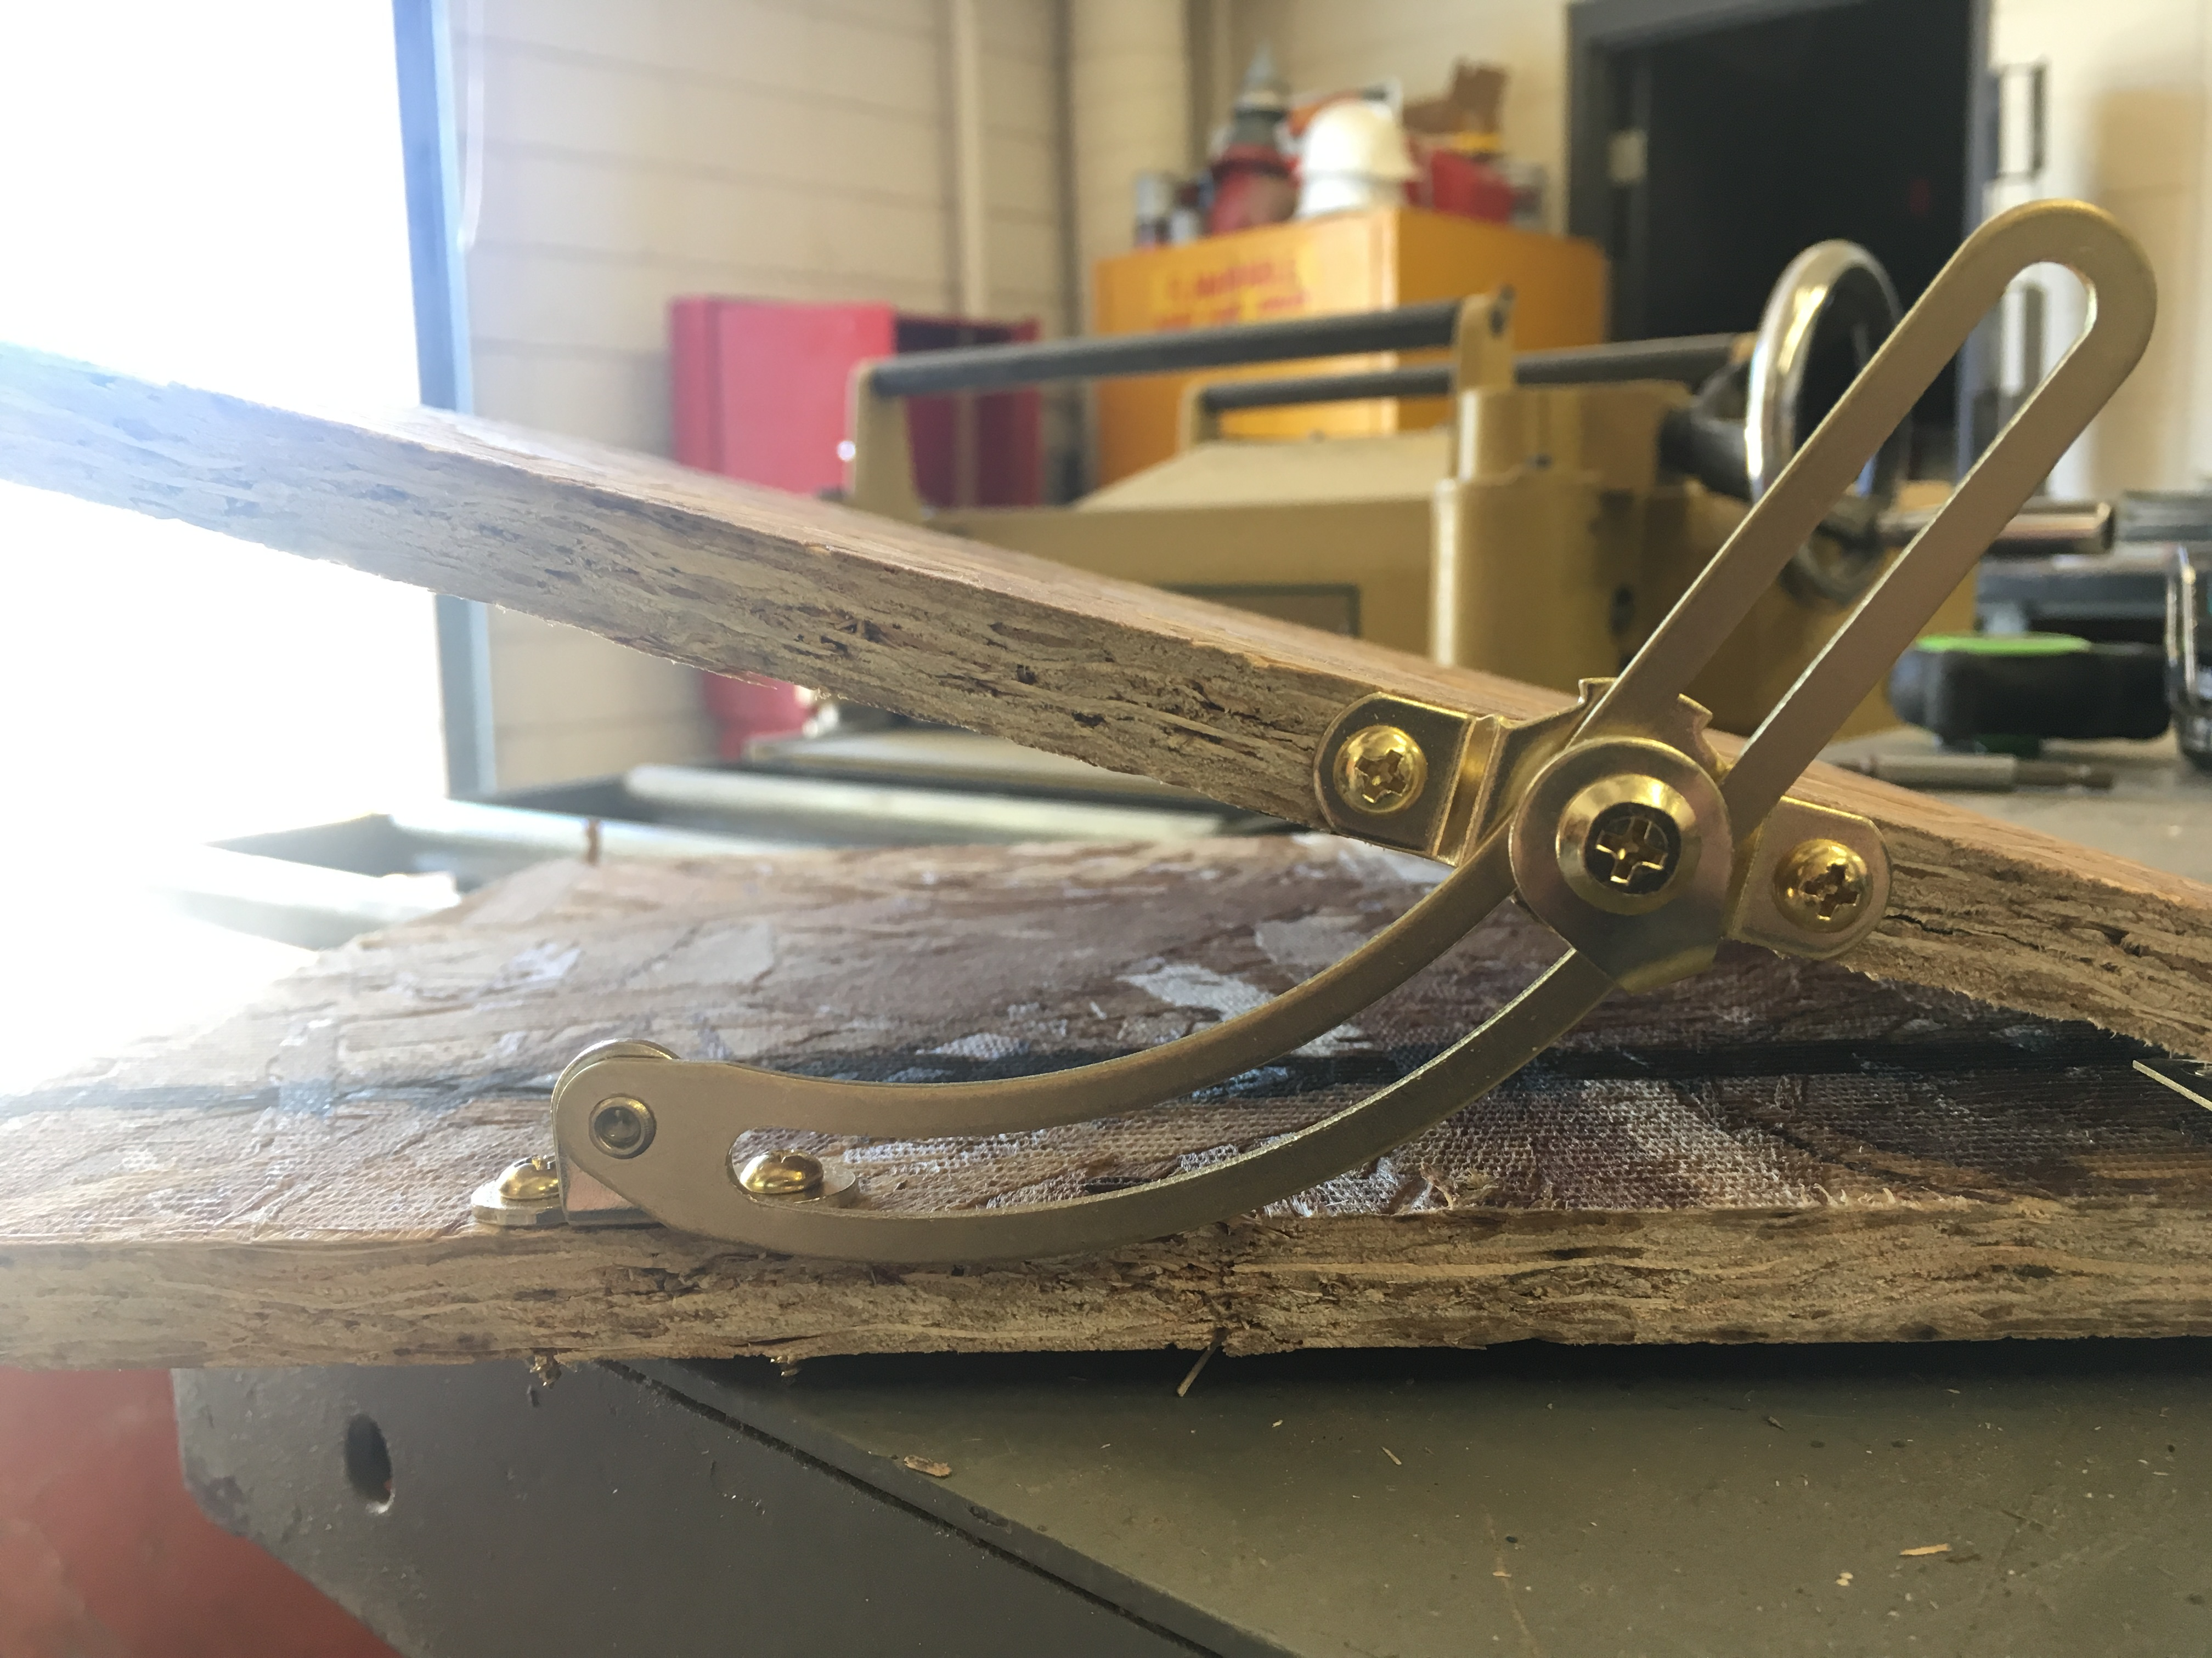

Step 4: Mount the Angle Board
- Use the 7.5” x 6” piece of plywood to mark a set of angles.
- Option 1 – Attached angle board (top pictures)
  - Using a pencil and a protractor (or framing square) mark angles in sets of 5 or 10 degrees.
    - Be sure to mark your 0 degree line while holding the angle board next to the tilt table. Depending of your plywood set-up, your 0 degree (horizon line) mark will be approximately 1 inch up from the bottom of the angle board.
  - Using the 1” wood screws, mount the board with the angles on the opposite side of the lid support to demonstrate the angle of the tilt table.
- Option 2 – Free standing angle board (bottom pictures)
  - Using a pencil and a protractor (or framing square) mark angles in sets of 5 or 10 degrees from the corner of the angle board.
  - Hold the board with the angles on the opposite side of the lid support to demonstrate the angle of the tilt table.
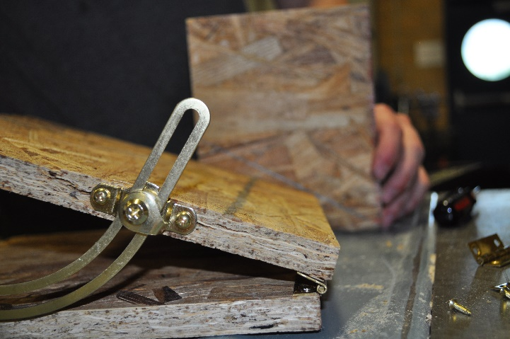
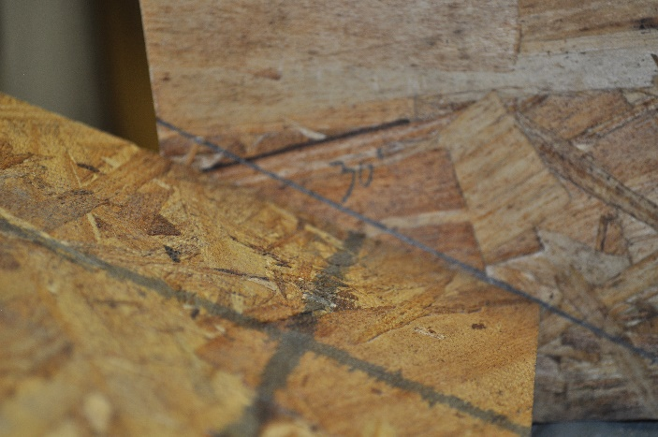
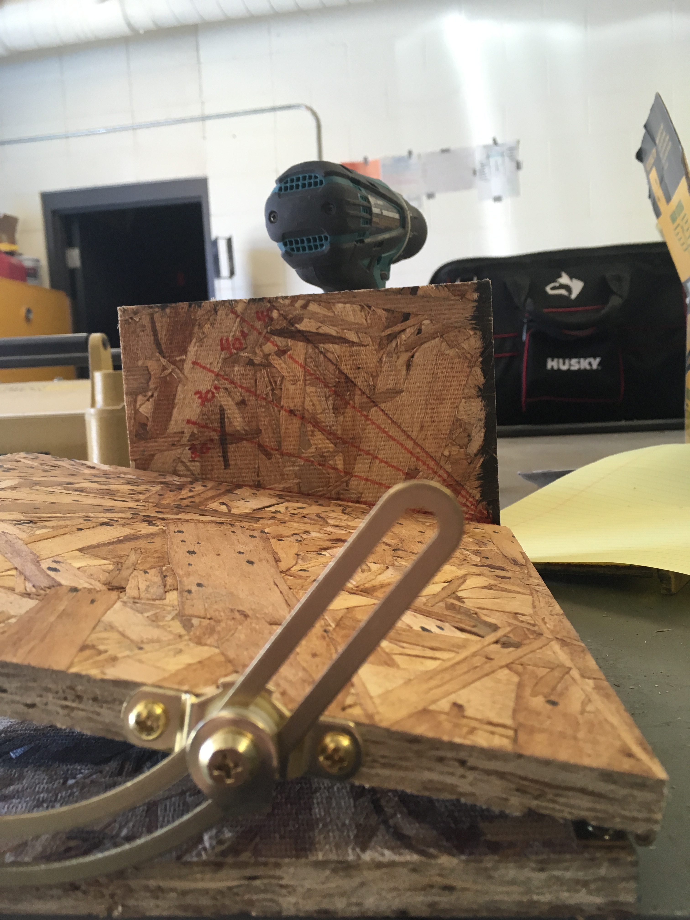

STOP HERE IF ONLY CONSTRUCTING TABLE

Note: The following is an abbreviated version of the Angles and Stability lesson plan. Please refer to the full lesson plans when incorporating into academic unit.

Using the table
- Place the tractor in the middle of the tilt table, with the table laying completely flat.
- Slowly raise the angle of the table by lifting up on the end of the table opposite the hinges.
- Make note of the angle at which the tractor finally tips over.
- If using a model tractor with a loader attachment, repeat the process, adjusting the loader bucket each time and see if the rollover point shifts.

Mr. Egg demonstration
- Attach a strip of Velcro to the bottom of one the eggs, as well as the seat of the model tractor without rollover protection.
- Place the egg in the tractor, securing with a rubber band around the base of the egg.
- Place the tractor and egg in the middle of the tilt table.
  - A metal tray can be placed at the base of the table to minimize the ensuing mess.
- Lift the table until the tractor and egg rollover, observe the effect on the egg.
- Repeat this process, only replace the tractor with one having a rollover protection system present.
  - You can also repeat the process, but exclude the rubber band.

Was there a difference in the outcome between the tractor with rollover protection and the one without? What about with or without a rubber band securing the egg?

